**EXPERIMENT-3**

**Student Name: Mohit Kumar**   **UID: 23MCA20175**

**Branch: MCA(General)**   **Section/Group: 23MCA3/A**

**Semester: 4th**   **Date of Performance: 12/02/25**

**Subject: WEB ANALYTICS**  **Subject Code: 23CAH-751**

1. **Aim/Overview of the practical:** Implement the on -page SEO for source code of the

website and generate backlinks for the website using different categories of backlinking generating website under off page SEO.

1. **Objective:** To optimize a website through On-Page SEO techniques and improve its search engine visibility by generating quality backlinks through Off-Page SEO methods.
2. **Apparatus:** 
   * WordPress
   * Yoast SEO

**Procedure:**

**Steps to build a report:**

**Yoast SEO:**

Yoast SEO is one of the most popular WordPress plugins designed to help optimize your website for search engines like Google. It simplifies the process of improving your site's SEO (Search Engine Optimization), which can help your site rank higher in search results and attract more visitors.

* + To check our SEO we goanna use Yoast SEO for it.
  + In Yoast SEO we can search how our site is performing and what we can do to improve it.

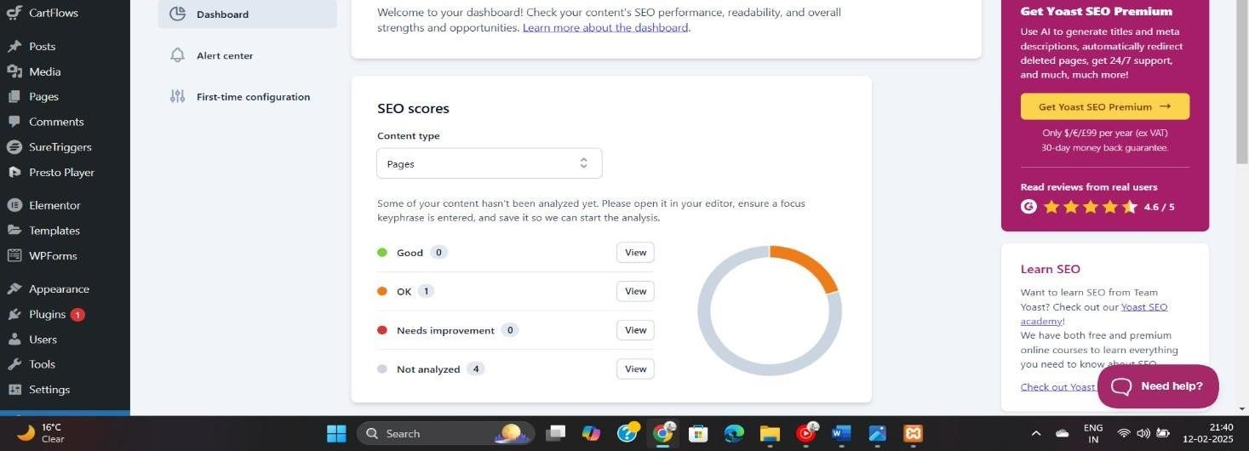

* + Like I have improved both SEO score and Readability in it.

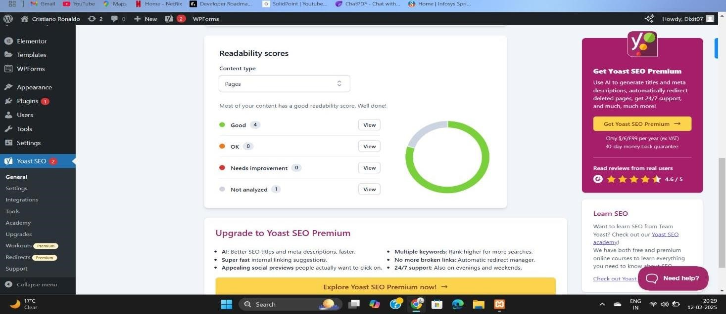

**ON-Page SEO:**

* + On-Page SEO refers to the practice of optimizing individual web pages to improve their search engine rankings and attract more relevant traffic. It involves both the content and the HTML source code of a page, unlike Off-Page SEO, which deals with external factors like backlinks.

Like in this page I have solve every problem it shows me in SEO.

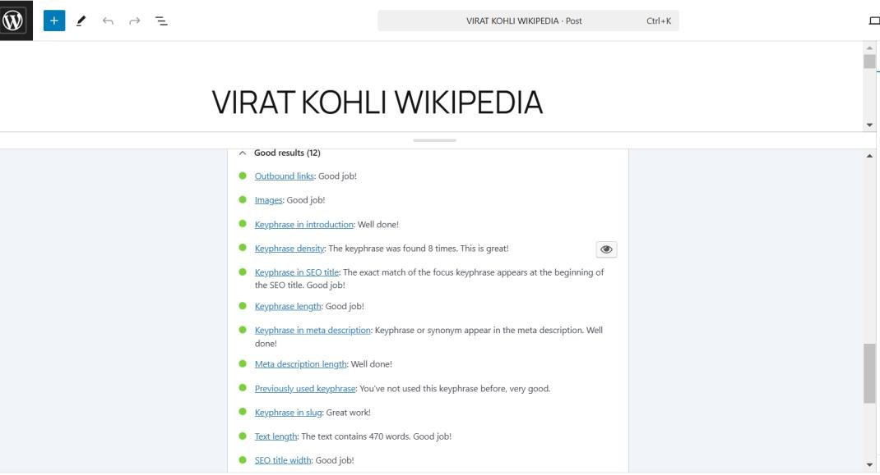

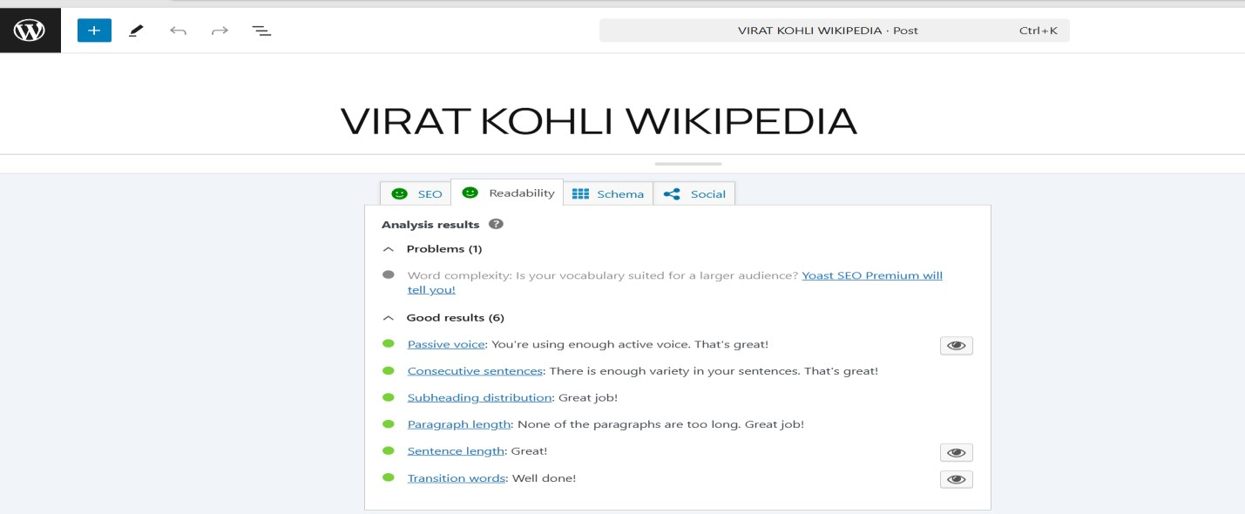

* + I have added keywords in it.
  + I have added key phrases in it.
  + I have added inserted links in it.

**Keyphrases:** Key Phrases (also known as focus keywords or target keywords) are specific words or combinations of words that people type into search engines when looking for information. These phrases help search engines understand the main topic of your content and match it with relevant search queries.

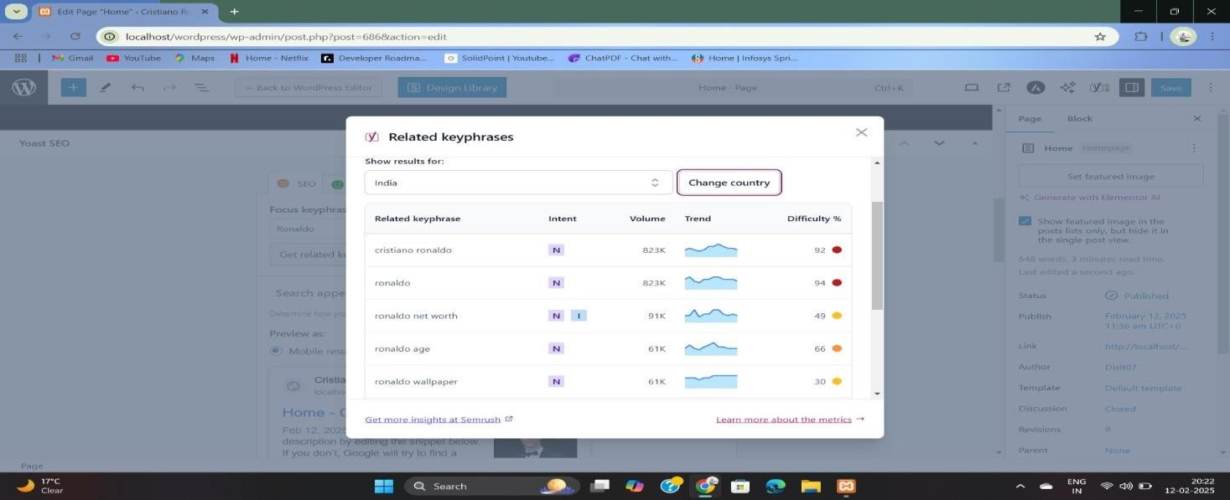

In this a added some key phrases so people can easily find our site.

By adding key phrases u can ensure that which word is used most to search your site most.

**Meta Description and SEO Title:**

The SEO Title (also called the *Meta Title* or *Title Tag*) is the clickable headline that appears in search engine results. It tells both users and search engines what your page is about.

The Meta Description is the short summary of your page that appears below the SEO title in search results. While it doesn’t directly impact rankings, it helps improve click-through rates by giving users a reason to click.

* Here u can see, I have described mine SEO title and Meta Description in it.
* In SEO title 50–60-word title id good.
* In Meta Description 150–160-word description is good.
* In both Orange colour means week and green colour means Strong.

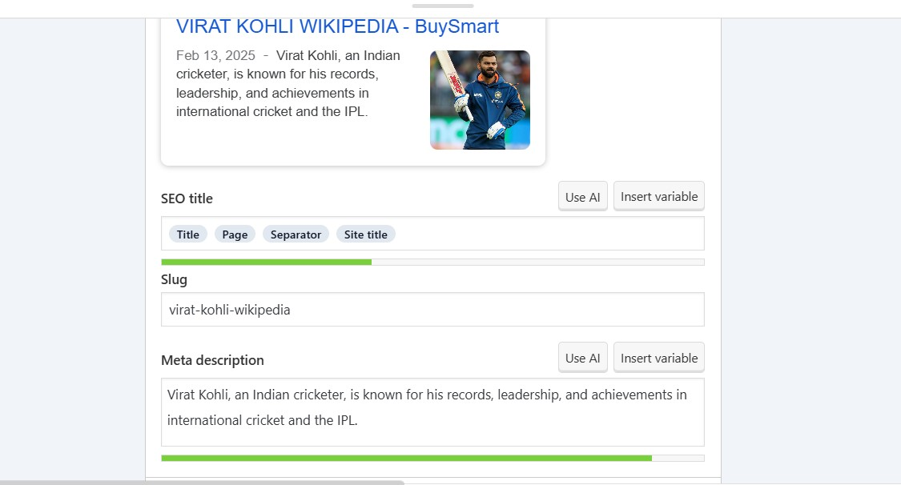

**After SEO site preview:**

* After applying every SEO function on it this is how it’s look.

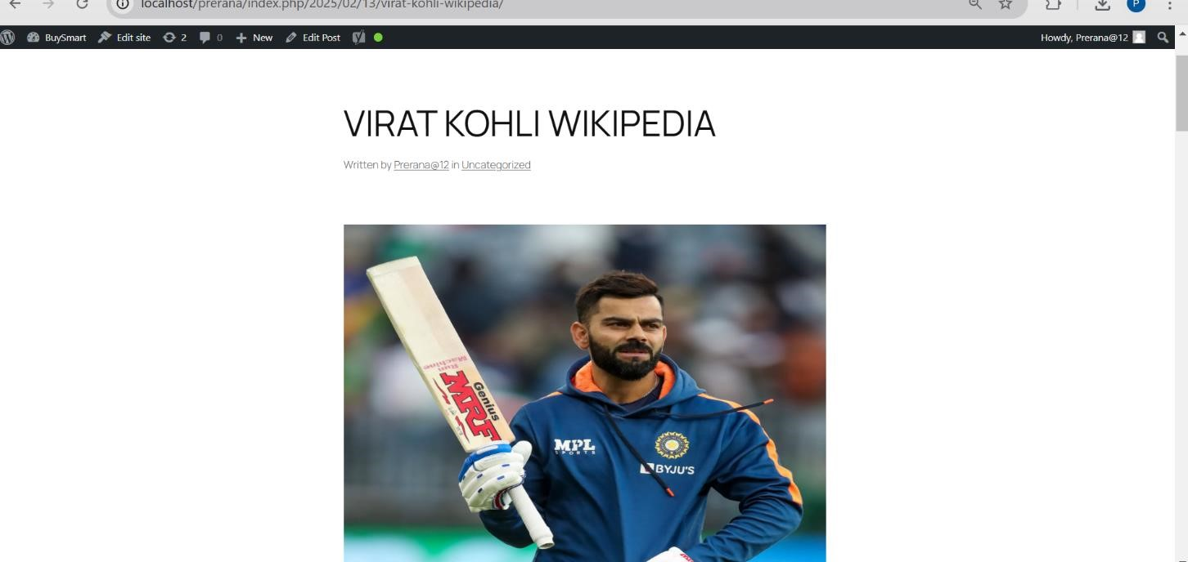

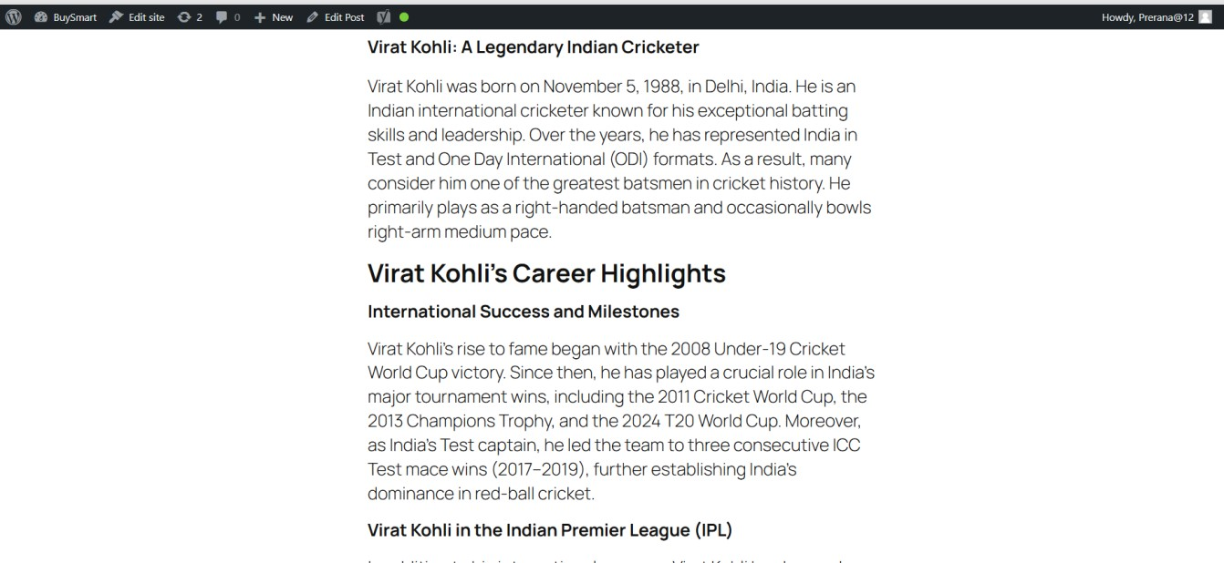

**Learning Outcomes:**

* Understand how to navigate the WordPress platform.
* Learn how to use Yoast SEO for site optimization.
* Learn how to modify themes, use plugins effectively, and customize page layouts.
* Understand how to using different categories of backlinking generating website under off

page SEO.